

January 22, 2008

Greetings Everyone!

Most of you will remember my trip to Dubai back in September and the hundreds of high rises being built. If I learned anything from that trip it is that we have to get off oil. Not because of man made global warming, which has not been proven, but rather because the entire world is shipping trillions of dollars to countries whose long term interests may be in direct opposition to our own. If you need reminding how much money we are shipping to these countries check out the latest news article from Saudi Arabia that I have attached to the bottom of this letter.

Ingenuity

It truly is a small world. Last week my sister emailed me a video link to the Michigan auto show. The video featured Henrik Fisker unveiling his new Fisker Automotive automobile known as the Karma. A small world because I know Henrik Fisker! I met him several years ago while admiring a few of his Fisker Coachbuilder designed autos. Fisker is well known in the auto industry for designing sexy high performance autos including the Aston Martin DB9.

Well I watched the video and immediately ordered his new Karma! The Karma will reduce my personal use of oil by 85-90%! I will also go from driving the least fuel efficient autos on the road to one of the most fuel efficient autos saving me a lot of money—money that would have gone to oil producing countries that would use my money against me and you! Best of all I’m not sacrificing styling and performance!

So here are some details about the Karma. I hope you will order one for yourself!

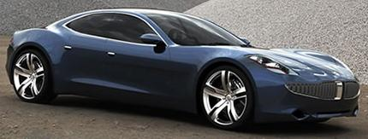

www.fiskerautomotive.com

http://autoshow.autos.msn.com/autoshow/Detroit2008/Article.aspx?cp-documentid=5895877

http://info.detnews.com/video/index.cfm?id=1782

http://youtube.com/watch?v=s5M9AZUNo2s

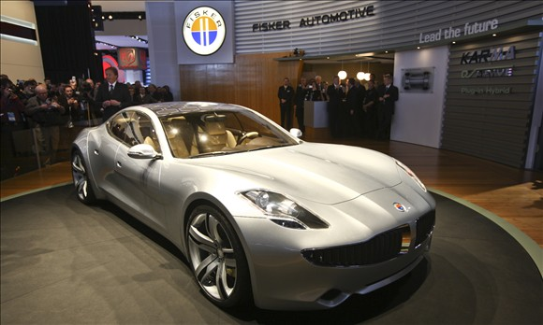

The Karma will go 50 miles using electric only or 650 miles with the gas engine charging the battery. 85-90% of my trips are 50 miles or less. So I won’t use any gas for most of my driving!

It's very fast 0-60 under 6 sec. which is awesome for a four door car! It has a 125 mph top speed. The gas engine only kicks in when your battery is running low. I figure I'll use about the same amount of gas in a year as I now use in 3 weeks!

You can plug the Karma into a 220 or 110 volt outlet at your home or elsewhere. In addition, Fisker Automotive is developing solar panels for your home so you don’t even have to use electricity from the grid! Electricity from the grid is super cheap so I doubt I’ll invest in the solar panels plus the Karma has its own solar panels built into its roof. If you leave the Karma in the sun it will charge its own batteries!

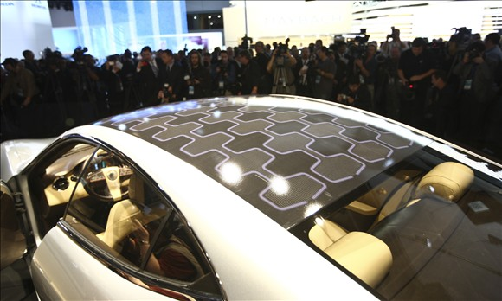

The Karma’s solar roof panels can also be used to cool the car while you are shopping. A nifty feature during our Arizona summers.

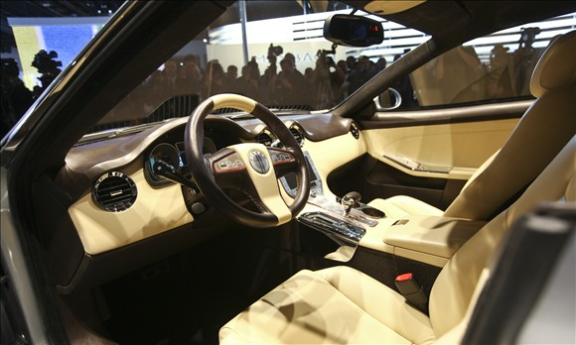

The Karma is not cheap but if you are not worth it who is? Those wishing to receive one of the first 99 Karma’s off the line during the fourth quarter of 2009 will pay around $100,000 and Henrik Fisker will personally sign it for you!

Those of you willing to wait a bit longer and forego Henrik Fisker’s personal signing will pay around $80,000 for deliver in 2010. I elected for a deliver in 2010 to save money and to allow Fisker to get any bugs out that may be present in the first batch! I have now officially be assigned number 135!

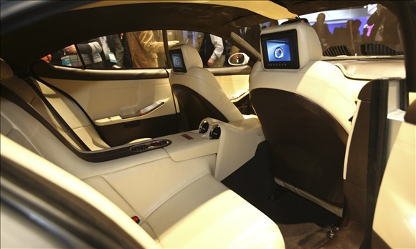

In addition to looking forward to my Karma I hope to feature Henrik Fisker as my Special Guest later this spring.

The Karma is a good example of the direction and speed we are moving in to propel us away from our dependence upon foreign oil producers. A good trend in deed.

Baron

Saudi Project – your money at work!

Article published Jan 20, 2008

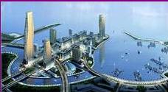

EMAAR DEVELOPMENT, VIA ASSOCIATED PRESS
A detail from a rendering of the King Abdullah Economic City, on the Red Sea. It is one of six new cities planned by Saudi Arabia as it works to diversify its economy beyond oil exports.
The Construction Site Called Saudi Arabia
JAD MOUAWAD
RABIGH, Saudi Arabia — THE alarm bell sounded the end of the lunch break here one November afternoon, and suddenly thousands of workers — on foot, on bicycles and in buses — streamed in, seemingly from out of nowhere, and jolted this huge construction site to life.
Amid a forest of cranes, towers and beams rising from the desert, more than 38,000 workers from China, India, Turkey and beyond have been toiling for two years in unforgiving conditions — often in temperatures exceeding 100 degrees — to complete one of the world’s largest petrochemical plants in record time.
By the end of the year, this massive city of steel at the edge of the Red Sea will take its place as a cog of globalization: plastics produced here will be used to make televisions in Japan, cellphones in China and thousands of other products to be sold in the United States and Europe. Construction costs at the plant, which spreads over eight square miles, have doubled to $10 billion because of shortages in materials and labor. The amount of steel being used is 10 times the weight of the Eiffel Tower.
“I’ve worked on many big things in my life, but I’ve never worked on anything this big,” an American project manager mused during a bus tour of the project, called Petro Rabigh, a joint venture of the state-run oil company Saudi Aramco and Sumitomo Chemical of Japan.
Size isn’t the only consideration. The project is Saudi Arabia’s boldest bet yet that this oil-rich kingdom can transform itself into an industrial powerhouse. The plant is part of a $500 billion investment program to build new cities, create millions of jobs and diversify the economy away from petroleum exports over the next two decades.
“The Saudi economy was in idle mode for 20 years,” said John Sfakianakis, the chief economist at SABB, formerly known as the Saudi British Bank, who is based in Riyadh, the Saudi capital. “Today, the feeling here is, ‘We’ve won the lottery; let’s not waste it.’ ”
The kingdom’s lofty economic goals would have been unthinkable without the surge in energy prices that has filled the coffers of oil producers. Oil prices have quadrupled since 2002 and reached $100 a barrel in New York this month.
Persian Gulf countries earned $1.5 trillion in oil revenue from 2002 to 2006, twice as much as in the previous five-year period, according to the Institute of International Finance, a global association of banks that is based in Washington. As the top exporter, Saudi Arabia has been the main beneficiary.
Despite all the recent headlines about Middle East investors bailing out troubled American banks like Citigroup, a growing share of today’s petrodollars are staying at home to finance mega projects like Petro Rabigh, analysts say. That money is financing the biggest economic boom in a generation, helping to build not only the high-rises of Dubai, where the world’s tallest tower is going up, but also telecommunications networks, roads and universities throughout the Middle East.
Abu Dhabi is planning to spend close to $1 billion for a new museum with the help of the Louvre, in Paris. Dubai’s latest grandiose idea is to build a small-scale replica of the French city of Lyon, complete with residential housing, a museum, a culinary school and a soccer club.
In Saudi Arabia, Riyadh looks like a boom town: sprawling over 40 miles, it is teeming with shopping malls, electronics stores and luxury boutiques. But while times are good today, many Saudis realize that their country is locked in a race against time to create industries that produce more than just oil in order to keep a young and growing population employed. The kingdom, which has a population of 24.5 million, including nearly 7 million foreigners, has what one analyst called a “human time bomb.” About 40
percent of Saudis are under 15, and because the country has one of the world’s highest birth rates, the population is expected to reach nearly 40 million by 2025.
“It has been a social, and therefore a political, imperative of the Saudi government to develop the economy and to create employment opportunities,” said Timothy S. Gray, the chief executive of HSBC Saudi Arabia.
That could well mean that higher oil prices are here to stay. One paradox of modern-day Saudi Arabia is that while it seeks to reduce the importance of petroleum to its economy, it needs those exports more than ever.
TO be sure, the region’s economies are too small to absorb all the oil riches on their own. Too much money is chasing too few assets, analysts say, forcing oil producers to invest some of their revenue abroad and diversify their holdings, either through opaque state-owned investment funds or through direct private investments.
Last year, for example, a fund controlled by the government of Abu Dhabi bought a stake in Citigroup for $7.5 billion, while another run by Dubai’s ruler bought a large share in Sony, the Japanese consumer electronics giant. Sabic, a major Saudi petrochemical company, bought the plastics division of General Electric for $11.6 billion, and the Kuwait Petroleum Corporation bought half of Dow Chemical’s commodity-plastics unit for $9.5 billion.
In recent weeks, other big banks plagued by losses from the mortgage crisis, like Merrill Lynch and Morgan Stanley, have raised tens of billions of dollars from a variety of Middle Eastern and Asian funds, including ones from Kuwait or Saudi Arabia.
According to data compiled by Bloomberg News, overseas investments by Persian Gulf countries reached a record $75 billion in 2007. Arms deals, a time-worn way of recycling petrodollars, remain popular in the region; the United States is pushing for a $20 billion weapons sale to Saudi Arabia, for example. But while oil-rich states are still buying American Treasury bonds or military hardware from the West, analysts say the more significant trend is for a growing share of their investments to be pumped into local
projects.
“The vision is to turn the kingdom into a major industrial power by 2020,” said Jean-François Seznec, a professor at Georgetown University who is a specialist in industrial policies in the Persian Gulf. “A billion dollars here and a billion there, and soon you’re talking about real money.”
Projects like Petro Rabigh, Mr. Seznec said, will allow Saudi Arabia to become one of the top three chemical producers in the world within a few years. Unlike Kuwait or Abu Dhabi, Saudi Arabia does not have a sovereign fund responsible for investing the country’s petroleum riches.
Ali Al-Naimi, the kingdom’s energy minister and one of the grand architects of Saudi industrial policy, summed up the country’s goals at the dedication ceremony for Petro Rabigh in 2006.
“I would like to highlight the fact that the Petro Rabigh project is part of a bigger picture,” Mr. Naimi said at the time. “This strategy includes expanding the base of the Saudi economy, diversifying national income sources, attracting international investments and reaping the direct and indirect benefits that these types of projects will accrue to the Saudi citizen.”
The trend to modernize and develop the economy is not entirely new, of course. Saudi Arabia has been trying to diversify itself for over two decades. It famously tried to make the desert bloom in the 1970s and
’80s by investing heavily in water desalinization plants and growing crops. But a long period of low oil prices, from the mid-1980s through the 1990s, stalled much of its effort. The government still relies on petroleum exports for 90 percent of its revenue; oil sales account for half of the country’s gross domestic product.
The current level of oil prices has given the country’s industrialization strategy a new spring, allowing the government to improve its finances while investing in large infrastructure projects. The Saudi G.D.P. has doubled in the last five years. Not counting oil, economic growth has been 4 percent to 6 percent a year since 2002.
Oil has not been the only engine of growth. The country’s private sector has also thrived and now accounts for 45 percent of the economy, compared with just 20 percent about 20 years ago. Since the 1990s, the share of private Saudi money invested at home has doubled, and now represents about 20
percent of total holdings, according to SABB.
“There is a lot of money looking for investment opportunities,” said Mr. Gray at HSBC. The financial turnaround has been spectacular. In 1999, the Saudi government’s debt amounted to 120 percent of G.D.P. That number has dropped to less than 20 percent as the government paid back its obligations
and put its finances in order.
Last year, the government recorded a budget surplus of $48 billion, five times the surplus of 2003. This year, it has built its biggest budget to date around a conservative estimate of oil prices of $45 a barrel; that will almost certainly yield a substantial surplus at the end of the year.
All of that is a far cry from the 1990s, when oil averaged $20 a barrel, thanks mostly to Saudi concerns at the time to keep oil prices low. One of the most noticeable illustrations of the industrialization push is a plan championed by King Abdullah, the 83-year-old Saudi monarch, to build six new cities throughout
the country — including the King Abdullah Economic City on the western coast, near the city of Rabigh; the Knowledge Economic City, near Medina; and the Prince Abdulaziz bin Mousaed Economic City, in the north.
The intent is to create industrial centers that double as housing and commercial hubs for the country’s young and growing population. The Saudi Arabian General Investment Authority, a government agency, expects these cities to add $150 billion to the country’s G.D.P. by 2020, create one million new jobs and be home to as many as five million people.
Drawings of these new towns depict a cross of the futuristic “Blade Runner” and traditional Arabic design. But the new cities are also expected to become new industrial centers that focus on four main sectors: petrochemicals, aluminum, steel and fertilizers.
According to SABB, these cities together will have four times the geographical area of Hong Kong, three times the population of Dubai, and an economic output equal to Singapore’s. Other plans include building four refineries, two petrochemical plants and a modern graduate-level university with an endowment of $10 billion.
THE frenzied growth of the economy has had some serious downsides. Inflation has been rampant in the last year; food prices and rents have risen sharply. Traffic jams in Riyadh and other Saudi cities have become a constant affliction, while real estate values have soared and the construction sector is strained by a lack of workers.
The stock market, meanwhile, has yet to recover from its collapse two years ago. From 2000 to early 2006, the local Tadawul stock index surged from 2,000 points to a peak of 19,870, a return of almost 900 percent. But the overvalued market went into a panicky free fall that caused it to lose two-thirds
of its value in a matter of months.
After being flat for most of 2007, the market has recovered in the last quarter, gaining more than 40 percent. Still, its value is only about half that of its peak two years ago. One reason for the partial rebound was anticipation of the sale of shares in Petro Rabigh earlier this month. For the first time, Saudi investors
had a chance to buy a major asset linked to Aramco. The initial public offering, for 25 percent of Petro Rabigh, raised $1.23 billion and was the largest stock sale in Saudi history. The stock is expected to begin trading at the end of the month.
The project itself is still about a year away from completion. Once in operation, it will produce 2.4 million tons of plastics a year. This venture, along with dozens of other megaprojects, will firmly anchor Saudi Arabia as one of the world’s top suppliers of chemical products as well as oil.
“Saudi Aramco has a vision of itself as Exxon Mobil,” Mr. Seznec of Georgetown said, “except much bigger.”
-------------------

